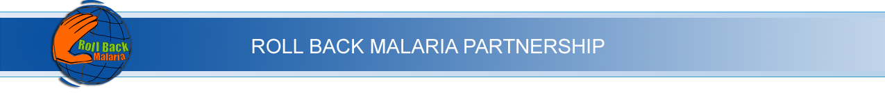RBM Communication Working Group
Task Forces

Communication Working Group task forces will work on a virtual basis, with ad hoc meetings as necessary for the completion of their tasks. Task forces may be disbanded and new ones constituted as the CWG members see fit.

At the inaugural meeting of the Roll Back Malaria Partnership Communication Working Group on 4-5 September 2003, five task forces were created:

Strategic Framework Task Force
Cheryl Lettenmaier (Chair)
Louis Da Gama
Angela Dawson
Amie Joof-Cole
Fiona Power
Graham Root
George Sikazwe

Capacity Building Task Force
Angela Dawson (Chair)
Elizabeth Fox
Graham Root
Patrick Wandawa

Linkages/Integration Task Force
Neil Ford (Chair)
Ben Adika
Cheryl Lettenmaier
Graham Root

Inventory of Tools and Approaches Task Force
Ben Adika (Chair)
Louis da Gama
Pru Smith
Susan Zimicki
[NB: This task force will work with the Communication Initiative and other network organizations to poll on a wider scale.]

Knowledge Management Task Force
Fiona Power (Chair)
Christine Kalume

In addition, the RBM Partnership Secretariat (led by Pru Smith) will set up a global advocacy group, which will include Massive Effort and other partners.

Timing
The chairs of the task forces will produce a workplan for each group, which will contain activities and dates. The chairs will send this plan to the RBM Partnership Secretariat by 15 October 2003.

